- Profile
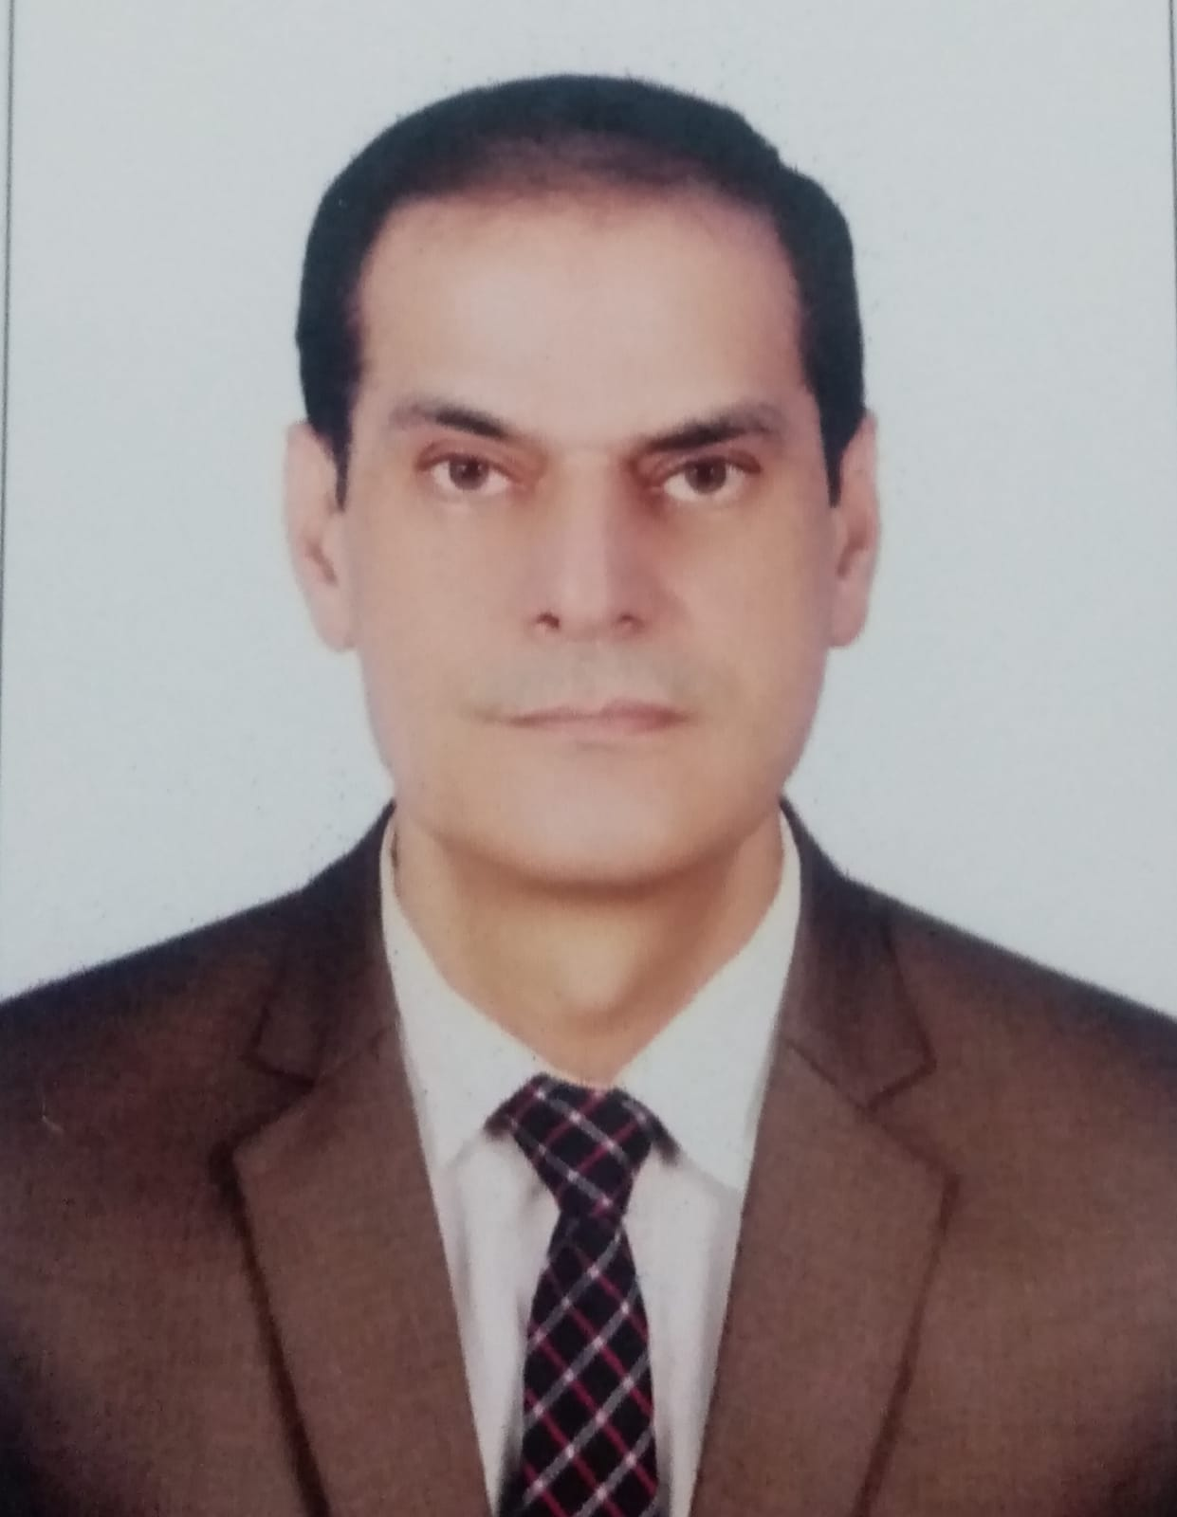
MUHAMMAD MASNA
A-40, Safari Comforts, Gulistan-e-Johar Block 12, Karachi, Sindh, Pakistan Cell:+92 332 3663008, Whatsapp: +92 3432020012
E-mail: alimasna@gmail.com
OBJECTIVE
To work in IT/Banking industry environment where achievements and performances are appreciated and professional growth is the demand of an organization.
EXPERIENCE

NKC Construction (Head Office) Nov 23 - Todate
- Admin Officer
Managing attendance record, checking salary petty cash, coordination with site / field staff, repairing and maintenance of
general office equipment, installation of hardware and software. Reporting to CEO.

XperTech Computers Mar 21 – Oct 23
- Owner of Computers and Laptops business. IT Consultancy, Office Automation, Networking services.
 Askari Bank

Area Coordinator, Karachi Area 4 (HR & MIS), Askari Bank, OG-I Apr 18 – Mar 21
- Arranging business meetings of 11 branches of Area 4.
- Arranging interviews, posting, transfers and functions of HR.
- Coordination with 11 branches of Area 4.
- Sending bills of expenses.
- Consolidation of MIS reports required on monthly, quarterly and annual basis.
- Coordination with Region office as well as HO, when required.

Documentation Officer (Agri), RCAD South, Karachi, Askari Bank, OG-I Dec 10 – Apr 18
- Documentation of Agriculture portfolio of about 700 customers.
- Coordination with ACOs of 15 branches of South region including Sindh and Baluchistan areas.
- Liasion with Agri & Rural Business Division based at Lahore.
- Sending exception reports, overdue reports, Fortnightly, Monthly, quarterly reports.
- Maintaining MIS, entry of collaterals, pools, facilities as well as overall limits in Flexcube Core Banking Software.
 Askari Leasing Limited

Head of MIS &IT Deptt, Askari Leasing Limited, Karachi, OG-II Jul 07 – Dec 10
- Network Administration with Active Directory, File Server, ISA Server, LBS/SQL Server.
- Re-designed & implemented the network of Askari Leasing Karachi, independently by ducting 45 nodes.
- Supervision, maintenance & troubleshooting of Network Infrastructure.
- Managing email accounts of branch users using IBM Lotus Notes.
- Installation of H/ware & S/ware, daily replication of LBS server to head office through VPN.
- Coordination with ISP personnel, vendors for support of Hyderabad & Sukkur Branch offices.

Operations Officer Apr 05 – Jun 07
Processing the applications of Auto leasing customers, recovery matters, looking IT issues like troubleshooting,installations of h/ware, s/ware, managing CIB vpn client, extracting CIBs, etc.


Akhai Galenika
- Assistant Manager IT & MIS Deptt Feb 04 – Apr 05
- Network Administration, troubleshooting, hardware / software, installations & error handling.

Industrial Castle Equipments
- IT Coordinator Dec 2k – Jan 04
- Network Installation, Administration, troubleshooting.
- Correspondence with foreign clients through electronic media like email, fax etc.

The Computer School
- Network Administrator Jan 98 – Nov 2k
- Administration of peer to peer network of 6 nodes, teaching networking & other subjects.

EDUCATION
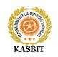

- MBA (MIS) from KASBIT, Karachi 3.04 CGPA 2016
- Masters in Computer Science (University of Sindh Jamshoro) 2nd Division 1995
e
- Bachelors in Computer Science (University of Sindh Jamshoro) 2nd Division 1994

TRAINING & COURSES / PROJECTS

- Lending Fundamentals, 02 days training conducted by Askari Bank Training academy from April 09 to April 10 2018

- Credit Administration, 2 days training conducted by Askari Bank training academy from May 7 to May 8 2015.

- Commercial Financing (Flexcube Module), 2 days training conducted by AKBL training academy 26-27 July 2011.

- Attended 01 day training on IT Products of Askari Bank, conducted by Askari Bank Limited on 03/12/2010.

- Attended 02 days training in Info. Security Management System conducted by Askari Bank on 15/11 to16 /11/2010.

- Microsoft Certified Systems Engineer (FROST International Karachi) A Grade 2000
- Completed MCSE 2003 (CTTC Karachi) A Grade 2010

- Thesis submitted for MBA requirement on topic “Analysis of key factors in the adoption of Mobile Banking”
- Independently created the network of 08 nodes workgroup for Human Development Fund, Karachi.
- Independently designed, implemented and maintained the network of 45 nodes domain in Askari Leasing Ltd.
WORKSHOPS ATTENDED

- Attended Workshop on Internet organized by SZABIST Karachi.
- Attended workshop on “Computer Trends in Pakistan” organized by University of Sindh in collaboration with

MAJU.
- Attended 02 days workshop on Management Information Systems at Rawalpindi Head Office & secured
Top Position in technical test among all over Pakistan branches of Askari Leasing Limited.
- Attended one day workshop on Microsoft Windows 2008 server organized by CTTC Karachi on 16/04/2010.
- Attended one day workshop on Linux System Administration organized by CTTC Karachi on 7/06/2010.


- Completed online three months Certificate Course on Freelancing from digiskills.pk 2020.

- Completed online three months Certificate Course on Digital Marketing from digiskills.pk 2020 .

- Completed online three months certificate Course on Wordpress from digiskills.pk 2020.
Hobbies
  - IT relevant books and literature

  - Studies
  - Very good player of Table Tennis, capable to represent any institution in major evrnts.
REFERENCES
- Will be furnished on request

